Annual results 2023: Robust business performance and strong capital base

- Rise in loan volume (+2.8%) and customer deposits (+3.9%)
- Strong equity base: CET1 ratio at 15.7%
- NPL ratio (2.3%) remains at low level
- Banking platform George reaches 10 million users
- Economies in CEE region return to growth path in 2024

Driven by a good operating performance and a favorable interest rate environment, Erste Group Bank AG recorded an operating result of 5.5 billion euros in 2023, an increase of 38% compared to the previous year. The cost/income ratio improved from 53.4% to 47.6%. The loan volume increased by 2.8% year-on-year from 202.1 to 207.8 billion euros, with 2.95 billion euros in sustainable loans granted in new business. Customer deposits also increased in all core markets, particularly in Austria and Czechia, to 232.8 billion euros (+3.9%). Around 10 million customers across Erste Group use George and every second product sale in the retail segment was digital. Net profit in 2023 amounted to 2.99 billion euros (2022: 2.17 billion euros). At the Annual General Meeting in May, the Management Board of Erste Group will propose a dividend of 2.70 euros per share for the 2023 financial year.

"Twenty years after the first EU enlargement involving Central and Eastern Europe, it’s clear that a real success story has been and is being written in the region. However, CEE is also facing major challenges that need to be overcome. The green transformation and advancing digitalization - all of this will require investment, for which we are available as a partner. One very welcome development: CEE is returning to its role as Europe's growth engine," says Willi Cernko, CEO of Erste Group.

"2023 was a strong year for our banking group. Despite the macroeconomic slowdown, we achieved an excellent result thanks to our loan volume growth and a favorable interest rate and risk environment. Even if the interest rate landscape is likely to change in the course of the current year: We are positioned to finance the ongoing upswing in our region," commented Stefan Dörfler, CFO of Erste Group, on the result for the 2023 financial year.

Profit and loss (P&L) 2023 compared with 2022; balance sheet 31 December 2023 compared with 31 December 2022

Earnings rise on larger loan volume, favourable market interest rates
Net interest income increased significantly to EUR 7,228 million (+21.5%; EUR 5,951 million), most strongly in Austria, on the back of higher market interest rates, as well as larger loan volume. Net fee and commission income rose to EUR 2,640 million (+7.6%; EUR 2,452 million). Growth was registered across all core markets, most notably in payment services but also in asset management and in lending. Net trading result improved to EUR 754 million (EUR -779 million); the line item gains/losses from financial instruments measured at fair value through profit or loss declined to EUR -306 million (EUR 731 million). The development of these two-line items was mostly attributable to valuation effects. Operating income increased to EUR 10,552 million (+23.1%; EUR 8,571 million).

Cost/income ratio improves to 47.6%, as operating result up 38.4%
General administrative expenses were up at EUR 5,020 million (+9.7%; EUR 4,575 million). Personnel expenses rose to EUR 2,991 million (+12.1%; EUR 2,668 million) driven by salary increases. The rise in other administrative expenses to EUR 1,468 million (+8.3%; EUR 1,356 million) was primarily due to higher IT and marketing expenses. Contributions to deposit insurance schemes included in other administrative expenses declined to EUR 114 million (EUR 143 million), most notably in Hungary (where in the comparable period of 2022, the Sberbank Europe deposit insurance case had resulted in higher expenses). Amortization and depreciation amounted to EUR 560 million (+1.7%; EUR 551 million). Overall, the operating result increased markedly to EUR 5,532 million (+38.4%; EUR 3,996 million). The cost/income ratio improved to 47.6% (53.4%).

NPL ratio rises slightly, but remains at low level
The impairment result from financial instruments (“risk costs”) amounted to EUR -128 million or 6 basis points of average gross customer loans (EUR -300 million or 15 basis points). Net allocations to provisions for loans and advances were posted in all core markets, with the exception of Croatia and Hungary. Positive contributions came from net releases of provisions for commitments and guarantees as well as from income from the recovery of loans already written off (in both cases most notably in Austria). The NPL ratio based on gross customer loans deteriorated slightly to 2.3% (2.0%). The NPL coverage ratio (excluding collateral) also slipped to 85.1% (94.6%).

Strong operating result, low risk costs bolster bottom line performance
Other operating result amounted to EUR -468 million (EUR -399 million). Expenses for annual contributions to resolution funds declined (most notably in Austria and the Czech Republic) to EUR 113 million (EUR 139 million). Banking levies – currently payable in two core markets – were lower at EUR 183 million (EUR 187 million). Thereof, EUR 137 (EUR 124 million) were charged in Hungary. In Austria, banking tax declined to EUR 46 million (EUR 63 million). Valuation effects had an adverse impact on other operating result.

Taxes on income amounted to EUR 874 million (EUR 556 million). The rise in the minority charge to EUR 923 million (EUR 502 million) was attributable to significantly better results from the savings banks – primarily due to higher net interest income. The net result attributable to owners of the parent rose to EUR 2,998 million (EUR 2,165 million) on the back of the strong operating result and low risk costs.

Loan volumes rise in both retail and corporate segments
Total equity not including AT1 instruments rose to EUR 26.1 billion (EUR 23.1 billion). After regulatory deductions and filtering in accordance with the CRR, common equity tier 1 capital (CET1, final) rose to EUR 22.9 billion (EUR 20.4 billion), as were total own funds (final) to EUR 29.1 billion (EUR 26.2 billion). Total risk – risk-weighted assets including credit, market and operational risk (CRR, final) – increased to EUR 146.5 billion (EUR 143.9 billion). The common equity tier 1 ratio (CET1, final) improved to 15.7% (14.2%), the total capital ratio rose to 19.9% (18.2%).

Total assets increased to EUR 337.2 billion (+4.1%; EUR 323.9 billion). On the asset side, cash and cash balances increased to EUR 36.7 billion (EUR 35.7 billion), loans and advances to banks rose to EUR 21.4 billion (EUR 18.4 billion), most notably in Austria and the Czech Republic. Loans and advances to customers rose to EUR 207.8 billion (+2.8%; EUR 202.1 billion) with both retail and corporate loan volumes up. On the liability side, deposits from banks declined to EUR 22.9 billion (EUR 28.8 billion). Customer deposits rose in nearly all core markets – most strongly in Austria and the Czech Republic – to EUR 232.8 billion (+3.9%; EUR 224.0 billion). The loan-to-deposit ratio stood at 89.3% (90.2%)

Outlook for 2024
The expectation by economists is for Erste Group’s core markets to post improved real GDP growth in 2024. Inflationary pressures are expected to continue their downward trend in 2024. Continued strong labour markets should be supportive of economic performance in all of Erste Group’s markets. Current account balances are projected to remain at sustainable levels in most countries, while fiscal deficits should continue their path of consolidation. Public debt to GDP in all Erste Group markets is projected to be broadly stable, and hence remain materially below the euro zone average.

Against this backdrop, Erste Group expects net loan growth of about 5%. Based on the macro outlook presented above, risk costs should remain at a low level in 2024. While precise forecasting is hard at current low risk cost levels, Erste Group believes that in 2024 risk costs will be below 25 basis points of average gross customer loans.

Erste Group’s goal for 2024 is to achieve a return on tangible equity (ROTE) of about 15%. The CET1 ratio is expected to remain strong, providing enhanced capital return and/or M&A flexibility, despite Erste Group targeting the execution of a share buyback in the amount of EUR 500 million in 2024.

CEE region’s unprecedented catch-up story enters a new phase
The year 2024 is marked by the 20th anniversary of the European Union enlargement that saw Czechia, Slovakia and Hungary among 10 states joining the EU in its largest accession round.

Over the past twenty years, the CEE region’s economies have made very significant advances, with the convergence process leading some of the region’s countries, like Czechia, to not only catch up to, but also surpass such Western European peers like Spain in GDP per capita (corrected for differences in purchasing power). Thanks to the long-term growth in CEE’s economies, the region’s individuals and households generally enjoy levels of prosperity that are sharply higher than two decades ago.

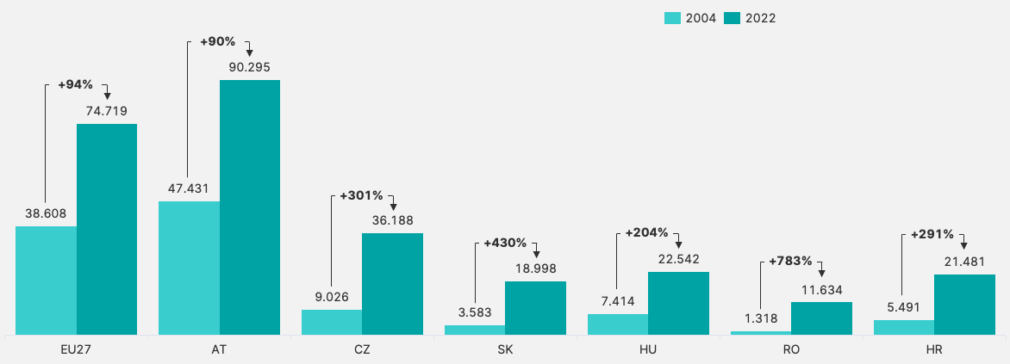
Financial Assets on a per capital basis (Euro)

Looking forward, the region’s countries must successfully meet the challenges of the “twin transitions” decarbonisation and digitalisation if they are to maintain and expand the prosperity their populations have generated. As a banking group deeply rooted in the region’s real economy and committed to advancing its prosperity, Erste Group will serve as partner, along with other actors from the financial and public sectors, in providing the financing necessary to make these twin transitions successful.

Media inquiries:
Erste Group | Press Department, Am Belvedere 1, 1100 Wien
Christian Hromatka, 050100 - 13711, E-Mail: christian.hromatka@erstegroup.com
Peter Klopf, 050100 - 11676, E-Mail: peter.klopf@erstegroup.com
Martin Sonn-Wende, 050100 - 11680, E-Mail: martin.sonn-wende@erstegroup.com

Text also available on: https://www.erstegroup.com/en/news-media
If you do not wish to receive any media information from us in the future, please write an email to presse@erstebank.at.

